Name : ..................................... | Date : ..........................................................................

 | ENGLISH (06)  Vocabulary : in the classroom…

1./ In the classroom…

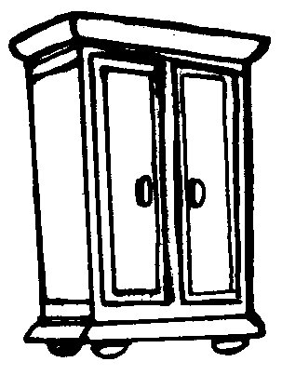 | 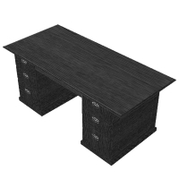 | 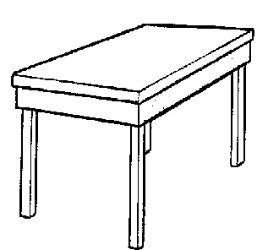 | 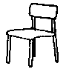
……………………..…………….. | ……………………..…………….. | ……………………..…………….. | ……………………..……………..
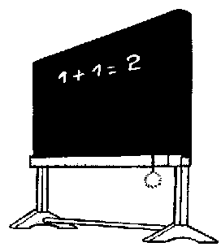 | 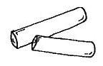 | 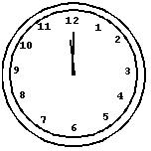 | 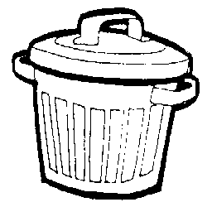
……………………..…………….. | ……………………..…………….. | ……………………..…………….. | ……………………..……………..

A table | A blackboard | A desk | Two chalks | A dustbin
 | A chair | A clock | A cupboard

2./ In the schoolbag…

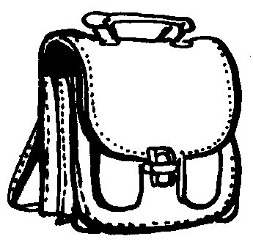 | 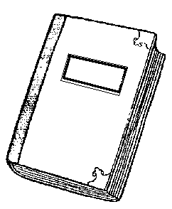 | 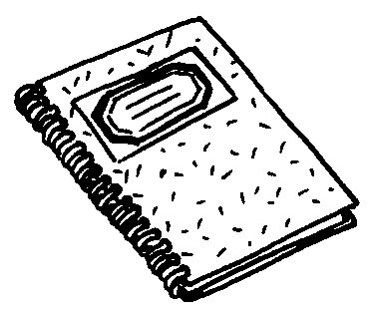 | 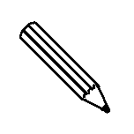
……………………..…………….. | ……………………..…………….. | ……………………..…………….. | ……………………..……………..
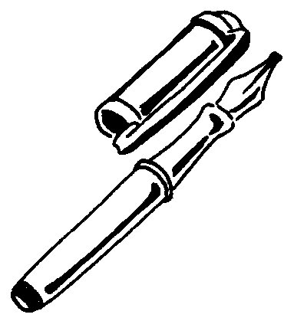 | 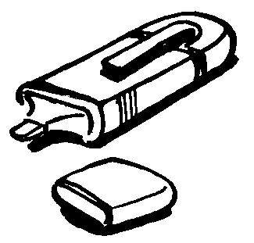 | 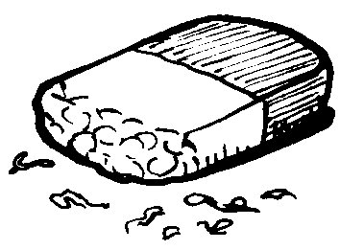 | 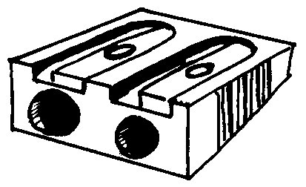
……………………..…………….. | ……………………..…………….. | ……………………..…………….. | ……………………..……………..
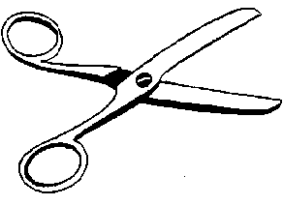 | 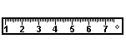 | 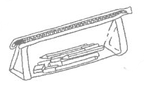 | 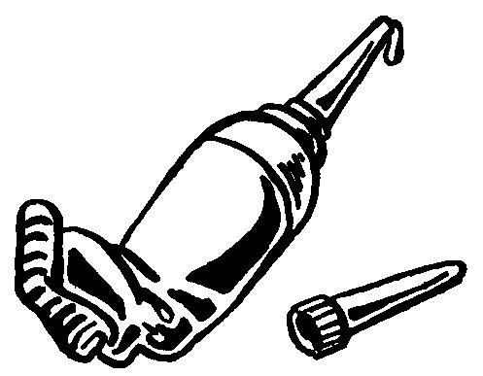
……………………..…………….. | ……………………..…………….. | ……………………..…………….. | ……………………..……………..

A schoolbook | A scissors | A pencil case |  | A marker
A pencil | A schoolbag | A ruler | A pencil sharpener
An ink pen | A tube of glue | An exercise book |  | An eraser

