Name : ..................................... | Date : ..........................................................................

 | ENGLISH (05)  Vocabulary : in the house…

1./ Complete with the right words : the house…

…………………….………….  …………………….………….  …………………….…………. | 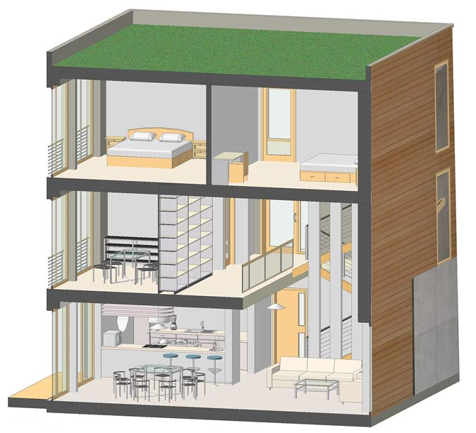 | The second floor  …………………….………….  The first floor  …………………….………….

the bedrooms | the living-room | the kitchen | the dining-room | the stairs

2./ Translate the following sentences :

On the second floor of this house, there are two bedrooms.

………………………………………………………………………………………………………………………………………………………………………..
The dining-room is very close to the kitchen.

………………………………………………………………………………………………………………………………………………………………………..
I can watch the television in the living-room.

………………………………………………………………………………………………………………………………………………………………………..
There is a swimming-pool in the garden.

………………………………………………………………………………………………………………………………………………………………………..

3./ Find the good words :

the city | a village | the street | a car | the church
…………………………… | …………………………… | …………………………… | …………………………… | ……………………………
the school | the supermarket | the crossroads | a bus | a building
…………………………… | …………………………… | …………………………… | …………………………… | ……………………………

un supermarché | une rue | une voiture | l’école | l’église
un village | un immeuble | Un bus | Un carrefour | Une ville

