Name : ..................................... | Date : ..........................................................................

 | ENGLISH (04)  The parts of the house…

1./ Complete with the right words : the house…

……………………..………  ……………………..………  ……………………..……… | 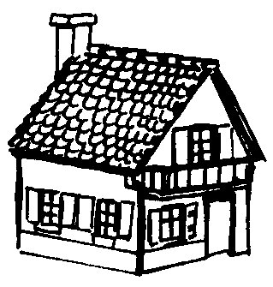 | ……………………..………  ……………………..………  ……………………..………

The roof | The door | The window
The wall | The balcony | The first floor

2./ Complete with the right words : the furniture…

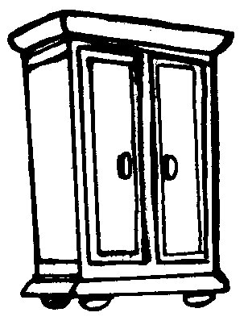 | 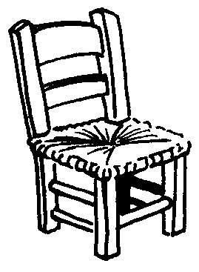 | 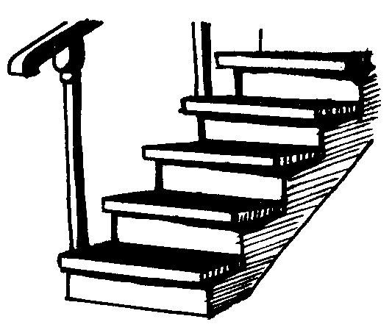
……………………………………………………. | ……………………………………………………. | …………………………………………………….
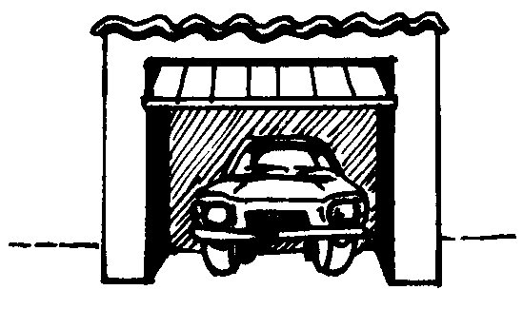 | 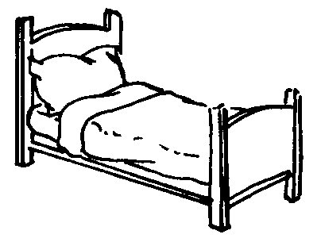 | 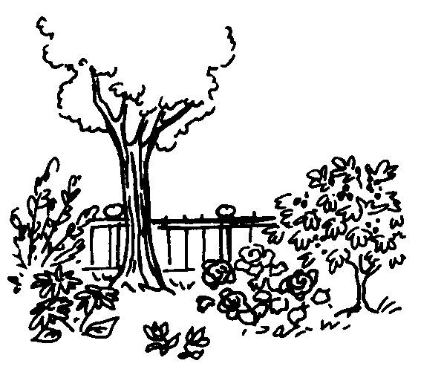
……………………………………………………. | ……………………………………………………. | …………………………………………………….
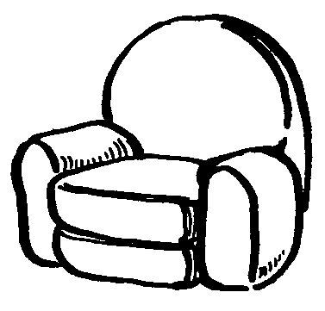 | 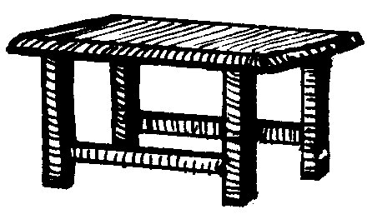 | 
……………………………………………………. | ……………………………………………………. | …………………………………………………….

The garden | A chair | A stairway
A table | A bed | The garage
A cupboard | A television | An armchair

