Name : ..................................... | Date : ..........................................................................

 | ENGLISH (03)  The parts of the body…

1./ Complete with the right words : the head…

……………………..………  ……………………..………  ……………………..……… | 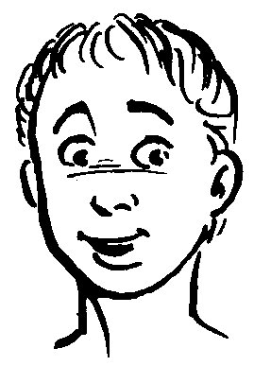 | ……………………..………  ……………………..………  ……………………..………

The eye | The nose | The hair
The mouth | The neck | The ear

2./ Complete with the right words : the body…

……………………..………  ……………………..……… | 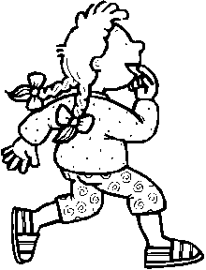 | ……………………..………  ……………………..………  ……………………..………  ……………………..………

The hand | The foot | The head
The arm | The leg | The back

