Name : ..................................... | Date : ..........................................................................

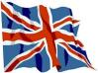 | ENGLISH (02)  What is the colour ?

1./ The colours :

black |  | white |  | red |  | green |  | blue

yellow |  | brown |  | pink |  | orange |  | purple

2./ Colour the pictures :

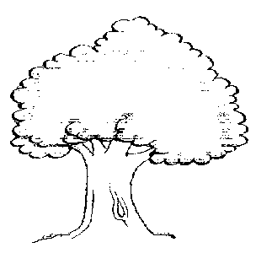 | 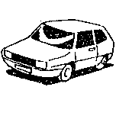 | 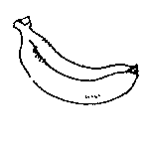
A TREE | A CAR | A BANANA

The tree is …………..……. and ………..………. .

The car is blue.

The banana is …………..……. .

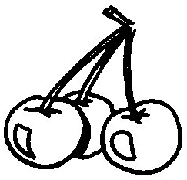 | 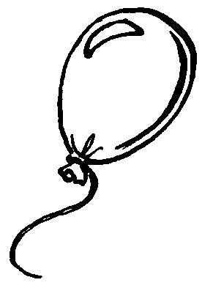 | 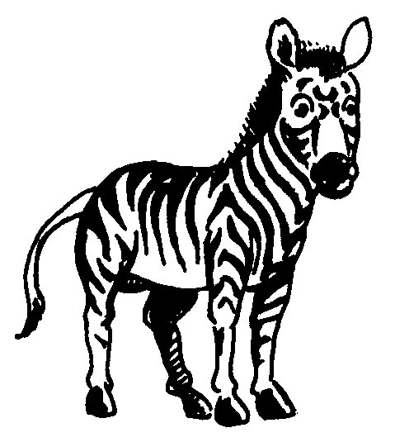
SOME CHERRIES | A BALLOON | A ZEBRA

The cherries are …………..……. .

The balloon is pink.

The zebra is …………..……. and …………..……. .

