Prénom : .................................... | Date : ...............................................................................

LES VÉGÉTAUX
Le cycle de vie des végétaux (Q)

- Décris chaque étape du cycle de vie du chêne :

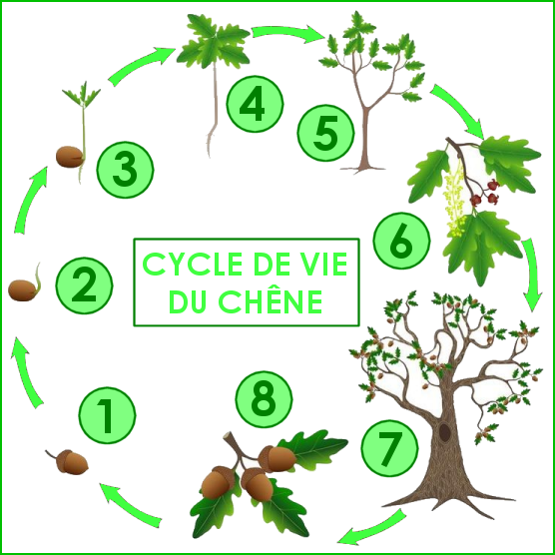 | 1 | ………………………………………………………………………………………….  ………………………………………………………………………………………….
 | 2 | ………………………………………………………………………………………….  ………………………………………………………………………………………….
 | 3 | ………………………………………………………………………………………….  ………………………………………………………………………………………….
 | 4 | ………………………………………………………………………………………….  ………………………………………………………………………………………….
 | 5 | ………………………………………………………………………………………….  ………………………………………………………………………………………….
 | 6 | ………………………………………………………………………………………….  ………………………………………………………………………………………….
 | 7 | ………………………………………………………………………………………….  ………………………………………………………………………………………….
 | 8 | ………………………………………………………………………………………….  ………………………………………………………………………………………….

