 | LA MONNAIE  Les euros (€) (A03)

Des équivalences…

 + | = 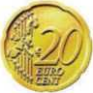
10 + 10 | = 20

+ + + + | = 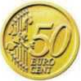
10 + 10 + 10 + 10 + 10 | = 50

++ | =
20 + 20 + 10 | = 50

100 euro cents = 1 euro

+ | = 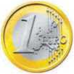
50 + 50 | = 1 €

+ + + + | =
20 + 20 + 20 + 20 + 20 | = 1 €

