Prénom : ................................ | Date : ...................................................................................

 | Je compte jusqu’à… 5 (07)

- Combien y a –t-il d’objets ? (Entoure ou écris la bonne réponse)

 |  |  |  |  |  |  |  |  |  | 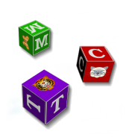 |  |  |  |  |  |  | 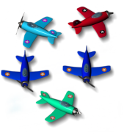 |  |  |  |  |  |  | 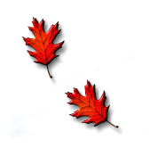
 | 0 |  |  | 2 |  |  | 4 |  |  | 3 |  |  |  |  |  |  |  | 1 |  | 3 |  | 5 |  | 2
 |  |  |  |  |  |  |  |  |  |  |  |  |  |  |  |  |  |  |  |  |  |  |  | 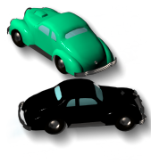
5 |  |  |  |  |  |  |  |  |  |  | 0 |  | 2 |  | 1 |  | 3 |  |  |  |  |  |  |  | 4 |  | 2 |  | 0
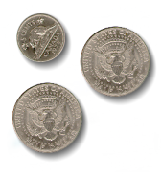 |  |  |  |  |  |  |  |  |  | 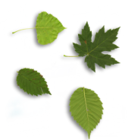 |  |  |  |  |  |  | 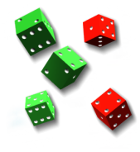 |  |  |  |  |  |  | 
 |  | 5 |  |  | 4 |  | 3 |  |  |  | 3 |  | 4 |  | 5 |  |  | 2 |  | 3 |  | 5 |  |  | 4 |  | 3 |  | 5
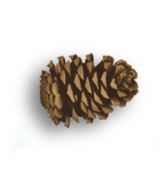 |  |  |  |  |  |  |  |  |  |  |  |  |  |  |  |  |  |  |  |  |  |  |  | 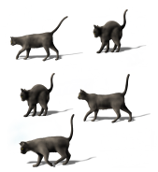
1 |  |  |  |  |  |  |  |  |  | 3 |  |  |  |  |  |  | 5 |  |  |  |  |  |  | 5

