Prénom : .......................................... | Date : .........................................................................................................

GÉOGRAPHIE - La Terre - Questions (04)

...............................................................................................................................................................

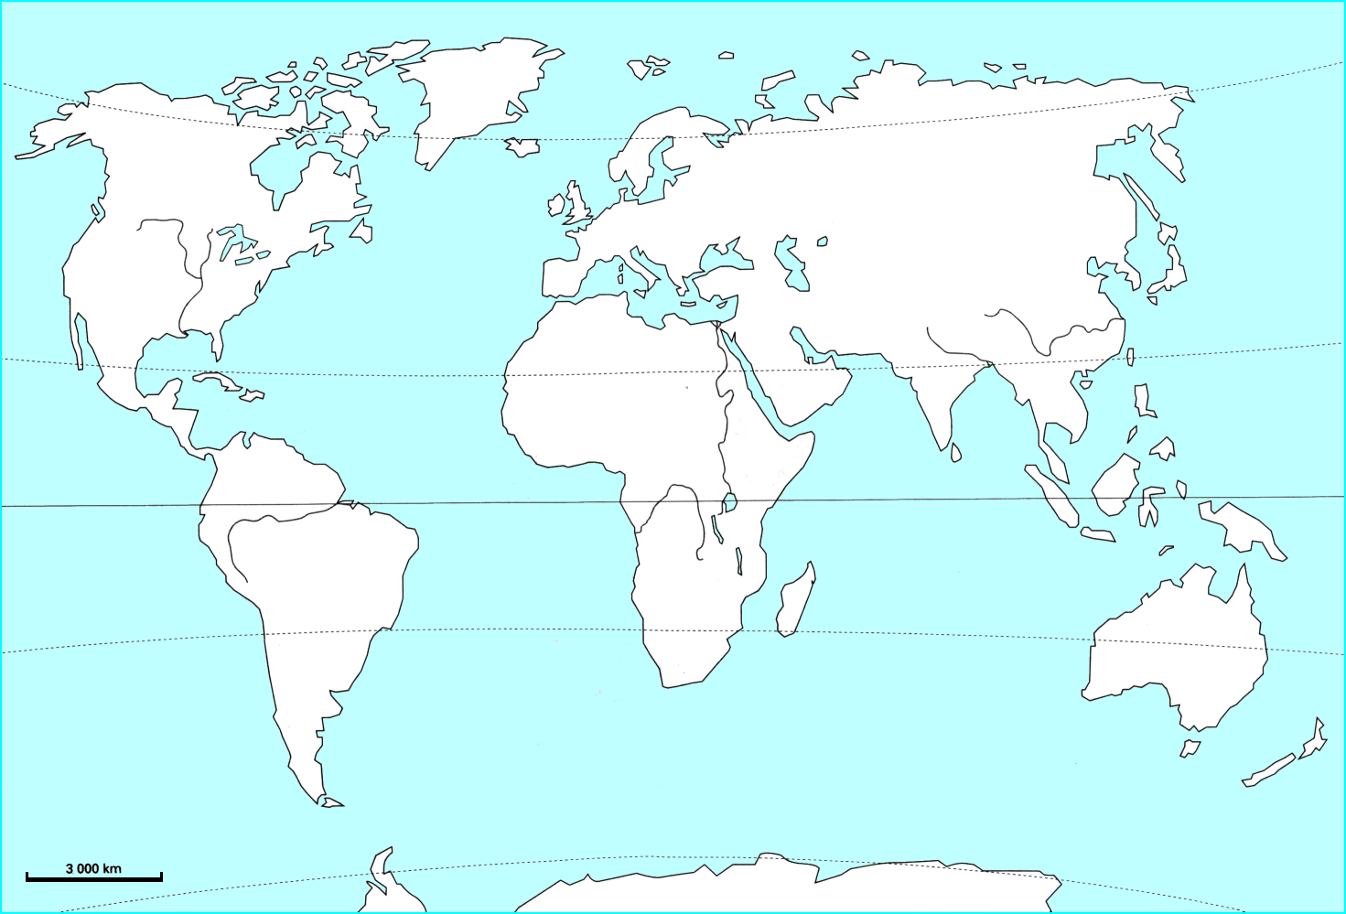 | Légende :  ..................................................................................  ..................................................................................  ..................................................................................  ..................................................................................  ..................................................................................  ..................................................................................  ..................................................................................  ..................................................................................  ..................................................................................  ..................................................................................  ..................................................................................  ..................................................................................  ..................................................................................  ..................................................................................  ..................................................................................  ..................................................................................  ..................................................................................  ..................................................................................

.....................................................................................................................................................................................................................................................................................................................................................

