Prénom : ……………………………………… | Date : …………………………………………………………...............…………

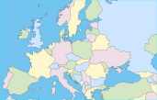 | GÉOGRAPHIE  Carte de l'Europe (M - 01)



























