Prénom : ………………………………. | Date : …………………..…………………………………….

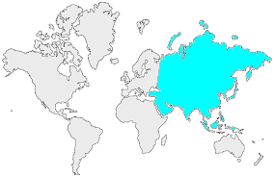16 | L’ASIE  Mots mêlés (1 - C)

- Retrouve les noms de 20 pays asiatiques dans cette grille :

G | I | M | O | N | G | O | L | I | E | M | S | S | T | J
W | Z | R | Z | V | J | P | R | M | C | C | L | E | I | I
C | N | A | B | I | L | D | E | I | R | Y | S | N | Z | E
H | A | F | G | H | A | N | I | S | T | A | N | I | R | M
I | N | A | T | S | I | K | I | J | D | A | T | P | U | A
N | B | H | O | U | T | A | N | W | R | V | B | P | O | N
E | I | S | I | A | L | A | M | D | J | Z | H | I | P | T
V | K | A | Z | A | K | H | S | T | A | N | C | L | A | E
C | B | K | N | E | I | N | A | M | R | I | B | I | G | I
R | V | F | N | Q | J | P | X | O | X | C | B | H | N | V
B | A | N | G | L | A | D | E | S | H | Z | R | P | I | G
R | E | D | N | I | S | I | N | L | R | T | K | X | S | I
Z | N | M | V | H | F | A | S | O | A | L | G | C | O | R
P | V | Y | O | B | R | E | G | D | O | B | M | A | C | A
G | V | J | X | I | G | X | B | J | A | P | O | N | O | K

- Pour t'aider voici leurs drapeaux :

 | AFGHANISTAN |  | KAZAKHSTAN
 | BANGLADESH |  | LAOS
 | BHOUTAN |  | LIBAN
 | BIRMANIE | 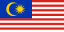 | MALAISIE
 | CAMBODGE |  | MONGOLIE
 | CHINE |  | PHILIPPINES
 | INDE |  | SINGAPOUR
 | IRAK |  | SYRIE
 | IRAN |  | TADJIKISTAN
 | JAPON |  | VIETNAM

