Prénom : ………………………………. | Date : …………………..…………………………………….

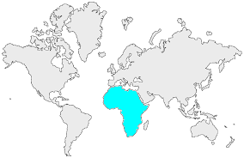16 | L’AFRIQUE  Mots mêlés (1)

- Retrouve les noms de 20 pays africains dans cette grille :

F | A | Y | N | E | K | S | G | A | M | B | I | E | X | C
N | U | O | R | E | M | A | C | S | O | X | A | Z | T | L
J | L | Z | H | J | N | F | U | U | H | L | B | B | A | E
E | N | L | A | G | X | K | S | B | A | D | U | I | N | U
W | O | B | O | M | R | P | O | E | J | Z | R | L | Z | Q
B | B | L | X | S | B | T | E | I | I | G | U | F | A | I
A | A | M | L | U | S | I | B | S | G | B | N | C | N | B
B | G | Z | F | W | B | O | E | I | I | O | D | T | I | M
M | S | H | A | I | U | S | T | N | L | F | I | C | E | A
I | A | N | M | T | P | O | E | U | A | B | O | C | I | Z
Z | A | A | I | N | G | M | N | T | M | R | S | C | C | O
B | N | N | U | M | R | A | C | S | A | G | A | D | A | M
N | A | M | A | J | L | L | O | M | Y | J | F | B | L | G
B | J | M | T | H | V | I | Z | N | Q | C | N | W | B | N
U | M | S | H | C | G | E | N | I | G | E | R | B | X | P

- Pour t'aider voici leurs drapeaux :

  

