 |  | A a | B b | C c
 |  | abeille | baleine | coq
 |  | 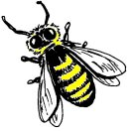 |  | 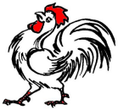
 |  | abeille | baleine | coq
 |  | A a | B b | C c

D d | E e | F f | G g | H h
dauphin | escargot | fourmi | girafe | hibou
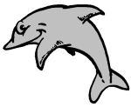 | 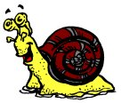 | 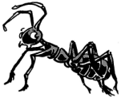 | 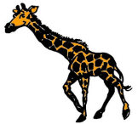 | 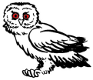
dauphin | escargot | fourmi | girafe | hibou
D d | E e | F f | G g | H h

I i | J j | K k | L l | M m
iguane | jaguar | koala | lion | mouton
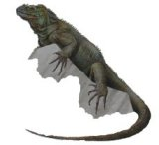 |  |  |  | 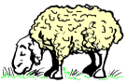
iguane | jaguar | koala | lion | mouton
I i | J j | K k | L l | M m

N n | O o | P p | Q q | R r
naja | otarie | panda | quetzal | renard
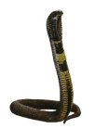 |  |  | 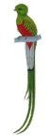 | 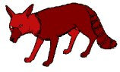
naja | otarie | panda | quetzal | renard
N n | O o | P p | Q q | R r

S s | T t | U u | V v | W w
serpent | tigre | urubu | vache | wapiti
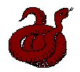 |  | 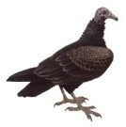 | 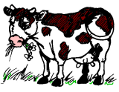 | 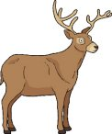
serpent | tigre | urubu | vache | wapiti
S s | T t | U u | V v | W w

X x | Y y | Z z
xiphophore | yack | zèbre
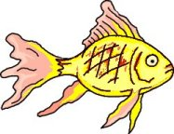 | 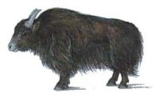 | 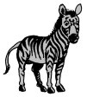
xiphophore | yack | zèbre
X x | Y y | Z z

