Prénom : ………………………… | Date : ………………………………………………………

 | ABÉCÉDAIRE (02)

A a | B b | C c | D d | E e | F f | G g | H h | I i | J j | K k | L l | M m
abeille | baleine | coq | dauphin | escargot | fourmi | girafe | hibou | iguane | jaguar | koala | lion | mouton
 |  |  |  |  | 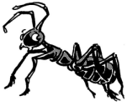 | 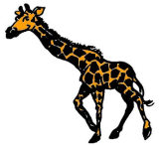 | 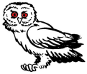 | 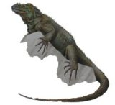 |  |  |  | 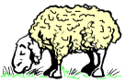
abeille | baleine | coq | dauphin | escargot | fourmi | girafe | hibou | iguane | jaguar | koala | lion | mouton
A a | B b | C c | D d | E e | F f | G g | H h | I i | J j | K k | L l | M m

N n | O o | P p | Q q | R r | S s | T t | U u | V v | W w | X x | Y y | Z z
naja | otarie | panda | quetzal | renard | serpent | tigre | urubu | vache | wapiti | xiphophore | yack | zèbre
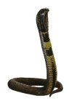 |  |  | 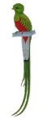 | 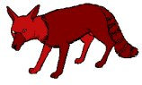 |  |  | 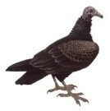 | 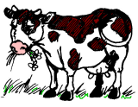 | 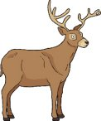 |  | 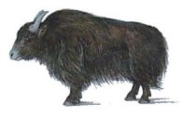 | 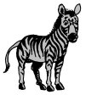
naja | otarie | panda | quetzal | renard | serpent | tigre | urubu | vache | wapiti | xiphophore | yack | zèbre
N n | O o | P p | Q q | R r | S s | T t | U u | V v | W w | X x | Y y | Z z

