on | on
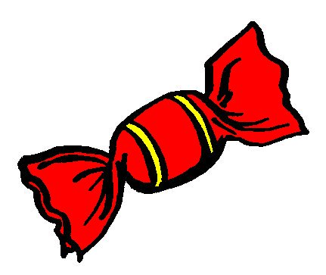

un bonbon
²un bonbon

