oin | oin
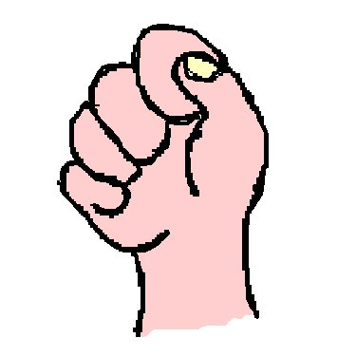

un poing
²un ²poing

