in | in
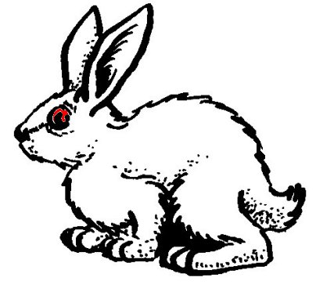

un lapin
²un lapin

