ied | ²ied
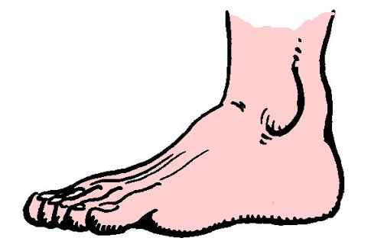

un pied
²un ²pied

