ll | LL | ll
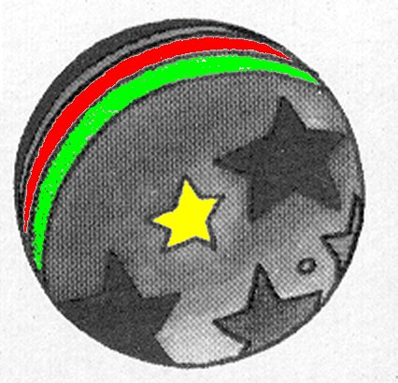

un ballon
²un ballon

